Below is the script used to finalize the result-

**Pig –x local;**

**emp_details = LOAD '/home/acadgild/pig/employee_details.txt' USING PigStorage(',') AS (emp_id:int, name:chararray, salary:int, rating:int);**

**emp_expense = LOAD '/home/acadgild/pig/employee_expenses.txt' USING PigStorage('\t') AS (emp_id:int, expense:int);**

**joined_data = JOIN emp_details by emp_id, emp_expense by emp_id;**

**extract_id_name = FOREACH joined_data GENERATE $0 AS emp_id, $1 AS name;**

**Final_result = DISTINCT extract_id_name;**

**dump Final_result;**

Each and every relation has been explained below with its immediate corresponding output-

Start pig in local mode-

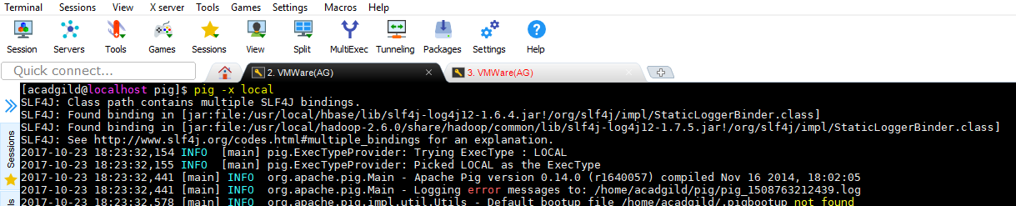

Load the emp_details.txt file using PigStorage

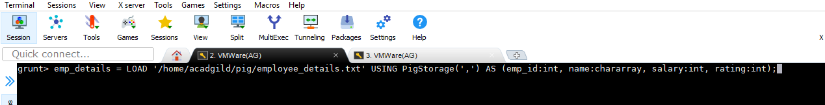

Contents of file-

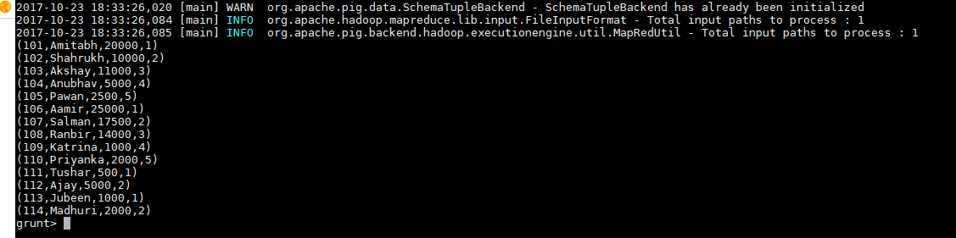

Load the emp_expense.txt file using PigStorage

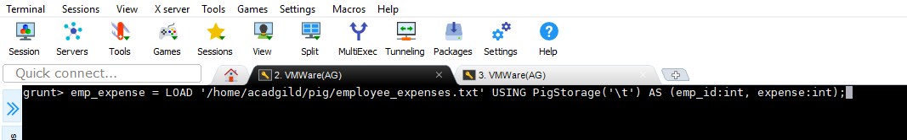



Contents of file-

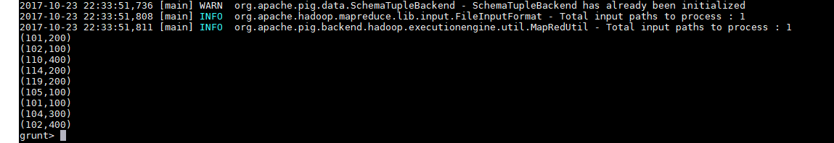

Join both files using JOIN relation-

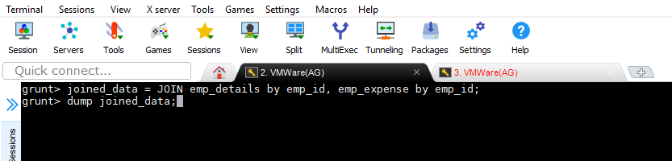

Result after JOIN

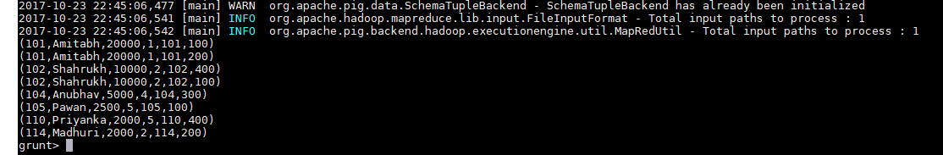

Extract EMP_ID and NAME as required-

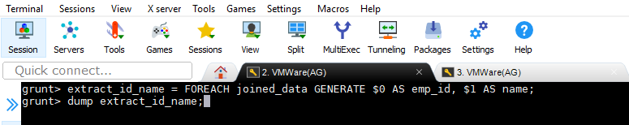

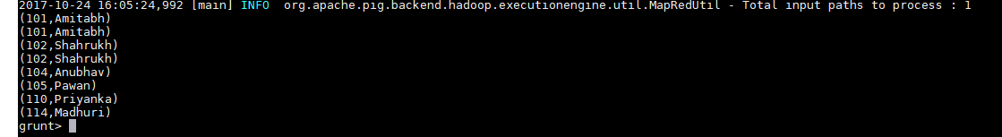

Take DISTINCT EMP_IDs -

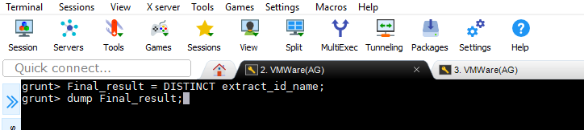

**FINAL O/P-**

